|  |
| --- |
|  |
| 新概念 3 册 |
| Lesson17 |

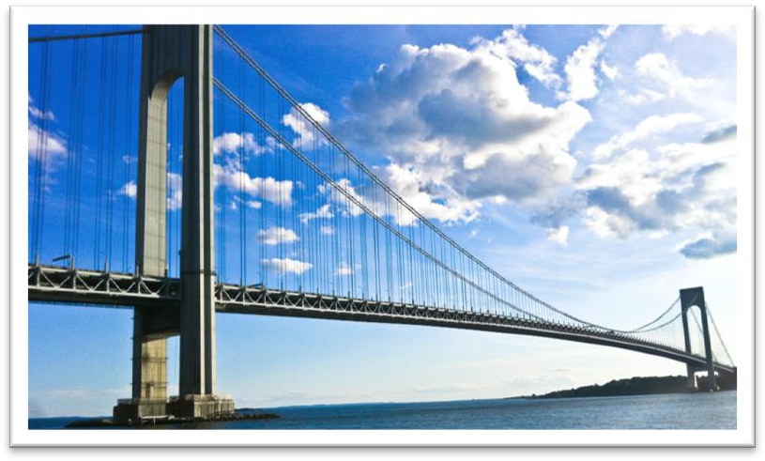Lesson 17 The longest suspension bridge in the world

**suspension [sə'spenʃn]**

**n. 悬挂；暂停；**

**（因违规而）停职，停课**

suspension bridge

the suspension of the peace talks

Annie got a 3-day suspension for smoking in school.

suspend sth. from sth.

A lamp was suspended from the ceiling.

Oddly shaped forms that are suspended from the ceiling and move in response to a gust of wind are quite familiar to everybody.

hang from sth.

In the corner of the room was a large lamp, hanging from the ceiling.

The ferry service has been suspended for the day because of bad weather.

A tiny asterisk conducted me to a footnote at the bottom of the page. It said: 'This service has been suspended.'

The policeman was suspended while the complaint was investigated. Dave was suspended from school for a week.

situation [sɪtʃu'eɪʃn]

**n. 地点，位置；情况，处境**

**situation location**

a beautiful situation / location overlooking the valley His apartment is in a really good situation / location. She found herself in an embarrassing situation.

This can give rise to curious situations, as it did in the case of Alfred Bloggs who worked as a dustman for the Ellesmere Corporation.

She tried to explain the situation, saying 'It's only me', but it was too late.

situate locate site

The monastery is situated / located / sited in a valley.

stand sit lie

Near the railway station stood a hotel.

The house sits on top of a hill The town lies on the coast. **immortal [ɪ'mɔ:tl]**

adj. 永生的；流芳百世的

Plato believed that the soul is immortal. the immortal Shakespeare

Emily Bronte's immortal love story

His telescopic observations are justly immortal; …

mortal

All human beings are mortal. a mortal wound

He became mortally ill a few months before we had planned to go and, when he knew that he was dying, he made me promise to go on my own.

immoral

It's immoral to steal.

moral

the decline of moral standards moral support / obligation

I know only that what is moral is what you feel good after and what is immoral is what you feel bad after.

― Ernest Hemingway

span [spæn]

**n. 跨度；一段时间**

The arch has a span of 60 meters.

I worked with him over a span of six years.

The project must be completed within a specific time span. Small children have a short attention span.

wingspan

a bird with a two-foot wingspan

lifespan

Men have a shorter lifespan than women.

A TV set has an average lifespan of 11 years.

concrete ['kɒŋkri:t]

**n. 混凝土**

modern buildings made of concrete

The towers are built on immense underwater platforms made of steel and concrete. a concrete floor / wall / building

concrete evidence / proposals / examples

Even if one didn't know from concrete examples (the 1936 Olympic Games, for instance) that international sporting contests lead to orgies of hatred, one could deduce it from general principles.

abstract

Beauty itself is abstract.

There are rare instances when justice almost ceases to be an abstract concept.

capacity [kə'pæsəti]

**n. 容量，承受量；能力**

**capacity of …**

The jug has a capacity of half a liter.

The stadium has a seating capacity of 50,000. The new truck has a loading capacity of 2.5 tons. **capacity for …**

He has a great capacity for work.

My capacity for mathematics is negligible.

capacity to do …

her capacity to read and write

We would lay less stress on 'facts and figures' and more on a good memory, on applied psychology, and on the capacity of a man to get along with his fellow-citizens.

ability to do …

Our ability to think and speak makes us different from other animals.

capability to do … capability of …

You have the capability to do / of doing this job well.

powers of …

Teachers have the responsibility to develop students' powers of critical thinking.

If parents were prepared for this adolescent reaction, and realized that it was a sign that the child was growing up and developing valuable powers of observation and independent judgment, they would not be so hurt, and therefore would not drive the child into opposition by resenting and resisting it.

aptitude for …

At an early age Susan showed an aptitude for languages.

Verrazano, *an Italian about whom little is known*, sailed into New York Harbour in 1524 and named it Angouleme.

know of / about … hear of / about … learn of / about …

I don't know him personally, though I know of / about him.

George was not too upset by his experience because the lady who owns the sweet shop heard about his troubles and rewarded him with a large box of chocolates.

Verrazano, an Italian *about* whom little is known, sailed into New York Harbour in 1524 and named it Angouleme.

They support the cables *from* which the bridge has been suspended.

在正式书面语中，若关系代词做介词宾语，需将介词置于关系代词之前，非正式文体无此限制。

（正式）This is the house *in* which I lived for 10 years.

➔（非正式）This is the house which I lived *in* for 10 years.

（正式）I have read the poem *of* which she is speaking.

➔（非正式）I have read the poem which she is speaking *of*.

about whom / which little is known

造句：Mary 和她的丈夫 Dimitri 住在 Perachora，一个鲜为人知的希腊小村庄。

Mary and her husband Dimitri lived in Perachora, a tiny Greek village about which little is known. 造句：张继，一位鲜为人知的中国诗人，曾经写过一首著名的诗歌，《枫桥夜泊》(“Mooring by Maple Bridge at Night”)。

Zhang Ji, a Chinese poet about whom little is known, once wrote a famous poem “Mooring by Maple Bridge at Night”.

name sb. …

We named our daughter Sarah.

name … after …

He was named after his father.

Tasmania was named after its discoverer, A. J. Tasman.

Though Verrazano is by no means considered to be a great explorer, his name will probably remain immortal, for on November 21st, 1964, the longest suspension bridge in the world was named after him.

He described it as *'a very agreeable situation located within two small hills in the midst of which flowed a great river*.'

describe … as (being) …

The man was described as (being) tall and dark, and aged about 20. Jim was described by his colleagues as (being) 'unusual'.

The old lady thought he was a fussy creature, but since the porter agreed with him, she rang up her daughter and asked for her help in what she described as a little spot of bother.

Those who never have to move house become indiscriminate collectors of what can only be described as clutter.

At the time, however, she was not only the largest ship that had ever been built, but was regarded as *unsinkable*, for she had sixteen watertight compartments.

agreeable adj. pleasant

We spent a most agreeable evening by the river.

He described it as 'a very agreeable situation *located* within two small hills in the midst of which flowed a great river.'

midst: middle

in the midst of the crowd

whilst: while

The days were hot whilst we were on vacation.

amongst: among

There is always hope that in its labyrinth of musty, dark, disordered rooms a real rarity will be found amongst the piles of assorted junk that litter the floors.

In the midst of two small hills *flowed* a great river.

➔ A great river *flowed* in the midst of two small hills.

全部倒装

**把全部谓语置于主语之前。**

**1、 表示位置或次序的状语置于句首，只要满足两个条件，要用全部倒装。**

①主语不是代词。②谓语动词不是及物动词。

A subway station *stands* in front of a huge shopping mall. In front of a huge shopping mall *stands* a subway station.

造句：这家饭馆的位置非常方便，位于一家大型购物中心的正中央，在购物中心前有一座地铁站。

The restaurant is in a very convenient situation. It is located right in the center of a huge shopping mall. A subway station stands in front of the shopping mall.

造句：这家饭馆的位置非常方便，位于一家大型购物中心的正中央，在购物中心前有一座地铁站。

The restaurant is in a very convenient situation located right in the center of a huge shopping mall in front of which stands a subway station.

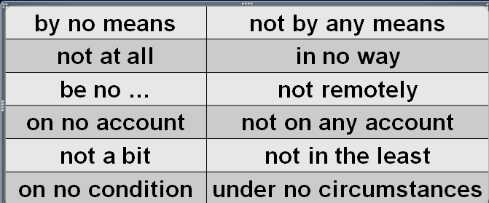Though Verrazano is *by no means* considered to be a great explorer, his name will probably remain immortal, *for on November 21st, 1964, the longest suspension bridge in the world was named after him.*

She is by no means pretty.

She's not a bad kid, by any means.

By no means *can* theory be separated from practice. She's not at all happy about the current situation.

This will in no way influence our original decision. I am no expert.

That girl is no fool.

Larry is no friend of mine.

His arguments are not remotely convincing.

On no account *must* you disturb me when I'm working. Do not on any account leave the prisoner unguarded.

I tried to convince them, but they weren't in the least interested. "Was she annoyed?" "Not a bit! She was delighted."

On no condition *should* untrained personnel use the equipment. Under no circumstances *will* we agree to splitting up the company. **consider … to be …**

We consider this (to be) very important. He was considered (to be) a weak leader. will remain immortal

The name of Lei Feng will remain immortal.

The tragic sinking of this great liner will always be remembered, for she went down on her first voyage with heavy loss of life.

will always be remembered

The tragic missing of the Malaysian airliner will always be remembered.

sth. be named after sb. sth. be named for sb.

**sth. be named in honor of sb.**

The college is named after / for / in honor of George Washington.

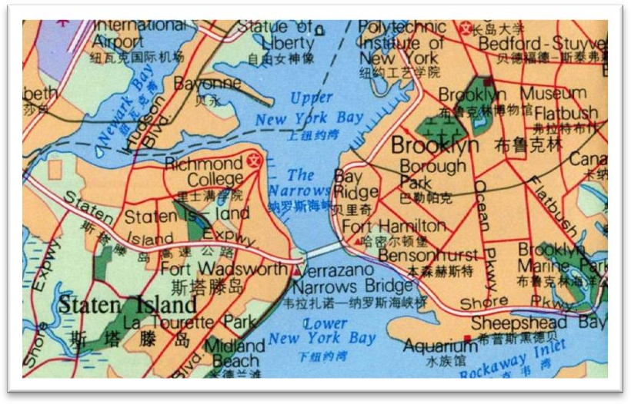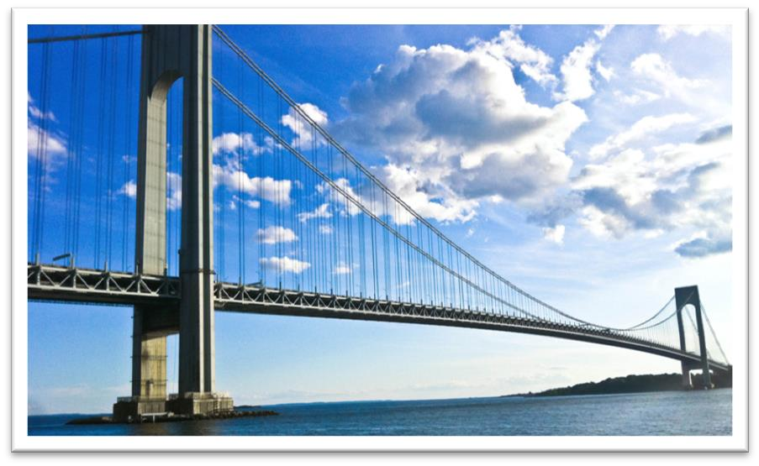

join A to B

The island is joined to the mainland by a bridge.

link A with / to B connect A with / to B

The Great St Bernard Pass connects Switzerland to Italy. The arch has a span of 60 meters.

It has a span *of* 4,260 feet. at the age *of* 52

an increase *of* 3%

a revenue *of* $3.4 billion

a pay raise *of* 4 percent

a salary *of* 30,000 dollars a year

The platforms extend to a depth *of* over 100 feet under the sea.

Above the surface of the water, the towers rise to a height *of* nearly 700 feet.

So long *is* the bridge that the shape of the earth had to be taken into account by its designer. The length of the bridge is such that the shape of the earth had to be taken into account by its designer.

Such *is* the length of the bridge that the shape of the earth had to be taken into account by its designer.

Such *is* human nature, that a great many people are often willing to sacrifice higher pay for the privilege of becoming white-collar workers.

The conditions of society are such that skills have to be paid for in the same way that goods are paid for at a shop.

take … into account

If you take *inflation* into account, we actually spend less now. We must take into account *the boy’s long illness*.

take account of …

These figures do not take account of changes in the rate of inflation.

take … into consideration

I always take *fuel consumption* into consideration when buying a car.

Before we come to a decision, we must take into consideration *all the relevant facts*. The candidates' experience will be taken into consideration.

The Titanic turned just in time, narrowly missing the immense wall of ice which rose over 100 feet out of the water beside her.

The train will depart from platform 3.

The speaker mounted the platform to denounce the policy. ferro-concrete

extend to a depth of …

The deepest known cave in the world is the Gouffre Berger near Grenoble. It extends to a depth of 3,723 feet.

go down to as much as …

The deepest holes of all are made for oil, and they go down to as much as 25,000 feet.

stand … high

She stood three feet high and her hands rested on her hips. rise to a height of …

Above the surface of the water, the towers rise to a height of nearly 700 feet.

How do I love thee?

How do I love thee? Let me count the ways.

I love thee to the depth and breadth and height my soul can reach.

― E. B. Browning These books alone cost me 2,000 yuan. Time alone will tell.

Persistence and determination alone are omnipotent.

― Calvin Coolidge

take (sb.) some time (to do sth.)

These alone took 16 months *to build*.

Even if you travel in ideal weather, sea journeys take a long time. It took me over half an hour *to get rid of him*.

The journalist immediately set out to obtain these important facts, but he took a long time *to send them*.

rise to a height of …

A tall steel tower rising to a height of nearly 200 feet will rest on the platform. Each of the four cables consists of 26,108 lengths of wire.

Each of the four cables is made up of 26,108 lengths of wire. Each of the four cables is composed of 26,108 lengths of wire. Each of the four cables comprises 26,108 lengths of wire.

a length of rope / pipe / wire etc a sum of money

a bar of chocolate a bar / cake of soap a slice of butter

a loaf of bread

a tube of toothpaste a cone of ice-cream

a bunch of grapes / bananas a flash / bolt of lightning

a peal of thunder a gust of wind

a pane of glass

a bouquet of flowers

It has been estimated that *if the bridge were packed with cars*, it would still only be carrying a third of its total capacity.

it is estimated that … it is said that …

**it is believed that … it is reported that …**

It is said that if anyone touches the tree, he will have bad luck; if he picks a leaf, he will die. It has been said that everyone lives by selling something.

“if” 型的虚拟语气

**1、与现在事实相反**。

If + S. + did / were, S. + would / should / could / might + do

If you lived in the Mediterranean, for instance, you *would* consider octopus a great delicacy. If she were alive today she *would* not be able to air her views on her favourite topic of conversation: domestic servants.

2、与过去事实相反

If + S. + had done, S. + would / should / could / might + have done

If they had only had one more child, the fact *would have passed* unnoticed.

If the Houses of Parliament had not been burned down in 1834, the great clock *would never have been erected*.

3、与未来趋势相反

If + S.+ should do, S.+ would / should / could / might + do

If + S.+ did / were to do, S.+ would / should / could / might + do If it should rain tomorrow, you *could* stay at home.

If the sun were to rise in the west, I *would* lend you the money.

If you were to ask Harry what was in the bottle, he *would* tell you that it contained perfumed mud.

be packed with … be crowded with …

**be crammed with … be thronged with …**

The island was packed with tourists.

The narrow roads were crowded with holiday traffic. The guide is crammed with useful information.

The streets were thronged with Christmas shoppers.

a third *of* … / one-third *of* … two-thirds *of* …

Two-thirds *of* the profits are given to charities.

Three-fourths *of* the public say they favor a national referendum on the issue.

Despite its immensity, it is both simple and elegant, fulfilling its designer's dream *to create 'an enormous object drawn as faintly as possible'*.

Although it is immense, …

Despite its importance, the meeting has to be postponed. Despite its scarcity, water is still wasted in the country.

Despite his cleverness, he cannot figure out how to do it.

fulfil / fulfill

**fulfill / realize / achieve one’s dream one’s dream come true**

**dream of doing sth. / to do sth.**

He had finally achieved his dream of becoming a pilot. Her dream to enter the famous university came true.

